Practical 5
Part A
1) | Shape areas: an abstract Shape with abstract area(); subclasses Circle, Rectangle,  Triangle. Put a mix in a Shape[] and loop once to print each area and the running total,  tracking the largest — one loop handling every shape through polymorphism.
 | ShapeDemo.java
Code | abstract class Shape { abstract double area(); }  class Circle extends Shape {  double radius;  Circle(double radius) { this.radius = radius; }  double area() { return Math.PI * radius * radius; }  }  class Rectangle extends Shape {  double length, width;  Rectangle(double length, double width) { this.length = length; this.width = width; }  double area() { return length * width; }  }  class Triangle extends Shape {  double base, height;  Triangle(double base, double height) { this.base = base; this.height = height; }  double area() { return base * height / 2; }  }  public class ShapeDemo {  public static void main(String[] args) {  Shape[] shapes = {new Circle(2), new Rectangle(4,5), new Triangle(3,6)};  double total = 0, largest = -1;  String name = "";  for (Shape s : shapes) {  double area = s.area(); total += area;  System.out.println(s.getClass().getSimpleName() + ": " + area  + " Running total: " + total);  if (area > largest) { largest = area; name = s.getClass().getSimpleName(); }  }  System.out.println("Largest: " + name + " " + largest);  }  }
Output | 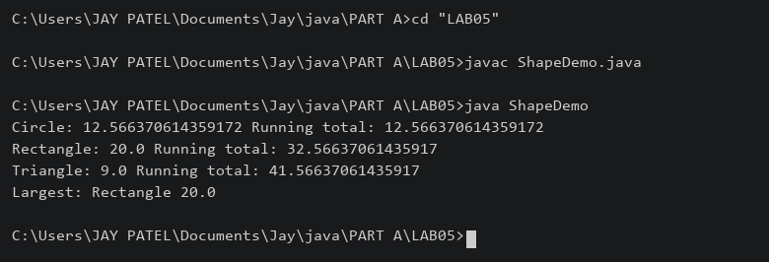

2) | Payroll: an abstract Employee with abstract monthlySalary(); FullTime (fixed), PartTime  (hours × rate) and Intern (stipend), each calling super for the shared name/id. Loop a  mixed array to print each salary and the total; use instanceof to add a note only for  interns.
 | Payroll.java
Code | abstract class Employee {  String name, id;  Employee(String name, String id) { this.name = name; this.id = id; }  abstract double monthlySalary();  }  class FullTime extends Employee {  double salary;  FullTime(String n, String id, double salary) { super(n,id); this.salary = salary; }  double monthlySalary() { return salary; }  }  class PartTime extends Employee {  int hours; double rate;  PartTime(String n, String id, int hours, double rate) {  super(n,id); this.hours = hours; this.rate = rate;  }  double monthlySalary() { return hours * rate; }  }  class Intern extends Employee {  double stipend;  Intern(String n, String id, double stipend) { super(n,id); this.stipend = stipend; }  double monthlySalary() { return stipend; }  }  public class Payroll {  public static void main(String[] args) {  Employee[] staff = {new FullTime("Tej","E1",30000),  new PartTime("Riya","E2",40,200), new Intern("Aman","E3",5000)};  double total = 0;  for (Employee e : staff) {  System.out.println(e.id + " " + e.name + " " + e.monthlySalary());  total += e.monthlySalary();  if (e instanceof Intern) { System.out.println("Intern stipend"); }  }  System.out.println("Total: " + total);  }  }
Output | 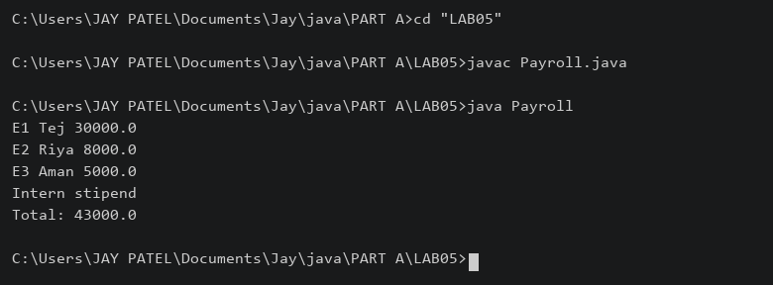

3) | (For Advanced Learners – home) Model a few media types that each compute a late fee  differently and total the fees for a returned batch. Design the hierarchy and rules yourself.
 | MediaDemo.java
Code | abstract class Media {  String title; int daysLate;  Media(String title, int daysLate) { this.title = title; this.daysLate = daysLate; }  abstract double lateFee();  }  class Book extends Media {  Book(String title, int days) { super(title, days); }  double lateFee() { return Math.max(0, daysLate) * 2; }  }  class DVD extends Media {  DVD(String title, int days) { super(title, days); }  double lateFee() { return Math.max(0, daysLate) * 5; }  }  class Magazine extends Media {  Magazine(String title, int days) { super(title, days); }  double lateFee() { return Math.max(0, daysLate - 1); }  }  public class MediaDemo {  public static void main(String[] args) {  Media[] items = {new Book("Java",3), new DVD("Movie",2),  new Magazine("Science",4)};  double total = 0;  for (Media m : items) {  System.out.println(m.title + ": " + m.lateFee()); total += m.lateFee();  }  System.out.println("Total fees: " + total);  }  }
 | Rules: Book Rs 2/day; DVD Rs 5/day; Magazine one free day, then Rs 1/day.
Output | 

